SCOTT DATABASE DEPT AND EMP TABLE

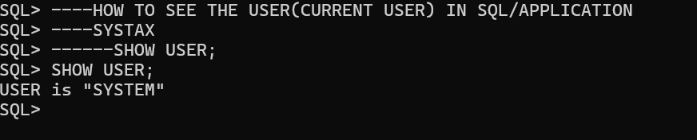

HOW TO SEE ALL THE USER IN SQL/APPLICATION

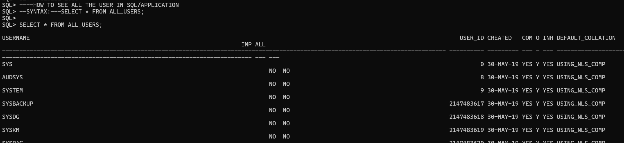

----HOW CREATE A NEW USER
----HOW TO CREATE TABLE IN NEW USER
----HOW INSERT DATE IN NEW USER TABLE
----HOW TO UPDATE DATA IN NEW USER TABLE
----HOW TO DELETE THE DATA IN NEW USER TABLE

STEP -1

Create user username identified by password;

CREATE USER SCOTT IDENTIFIED by tiger;
User created
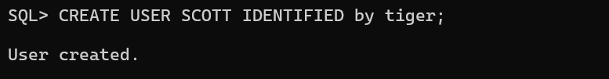

READ

NOW YOU HAVE CREATED THE USER
USER NAME IS SCOTT.

WE CAN NOT CONNECT WITH NEW USER SCOTT
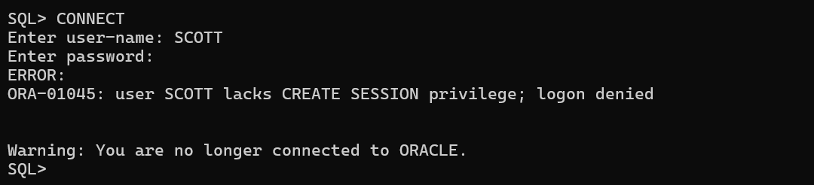

WE CAN NOT CREATE A TABLE IN NEW USER SCOTT
WE CAN NOT INSERT THE VALUES/DATE IN NEW USER SCOTT
WE CAN NOT UPDATE/MODIFY THE DATA/VALUES NEW IN USER SCOTT
WE CAN NOT DELETE/DROP THE DATA IN NEW USER SCOTT

CONCLUSION:- WITH OUT CONNECT WITH NEW USER WE CAN NOT CREATE/INSERT/UPDATE/DELETE THE DATE IN NEW USER SCOTT

------TO OVER COME THIS USER (SCOTT) NEED TO TAKE PERMISSION (PRIVILEGES)
----FROM DATABASE ADMINSTRATION (DATABASE ADMIN)
----WE HAVE DATABASE ADMIN i.e(system/tiger)

STEP-2

SQL> connect
Enter user-name: system
Enter password: tiger
Connected
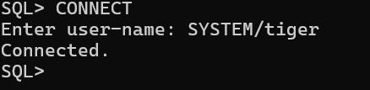

WE HAVE DATABASE ADMIN i.e(system/tiger)
TO CREAT/INSERT/UPDATE/DELETE DATA OF USER.
DATABASE ADMIN i.e (system/tiger)
SHOULD GRANT THE PRIVILEGES (PERMISSIONS) TO USER SCOTT

STEP-3
Grant all privileges to userName;
PRIVILEGES MEANS PERMISSION

SQL>GRANT ALL PRIVILEGES TO SCOTT; copy/past in SQL Appn
GRANT SUCCEEDED
(Or)
SQL>GRANT DBA TO SCOTT;
GRANT SUCCEEDED
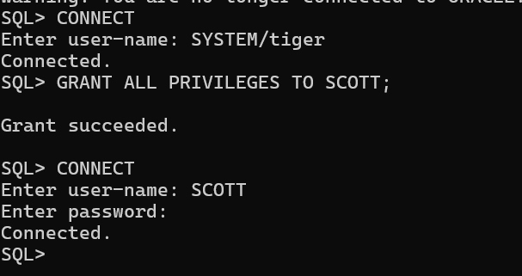

STEP-4

SQL>CONNECT
Enter user-name: SCOTT
Enter password: tiger

Create table DEPT
(
DEPTNO number(2) PRIMARY KEY,
DNAME varchar2(14),
LOC varchar2(13)
);

INSERT INTO DEPT VALUES(10,'ACCOUNTING','NEW YORK');
INSERT INTO DEPT VALUES(20,'RESEARCH','DALLAS');
INSERT INTO DEPT VALUES(30,'SALES','CHICAGO');
INSERT INTO DEPT VALUES(40,'OPERATION','BOSTON');

SELECT * FROM DEPT;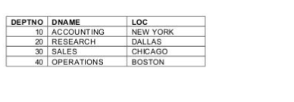
COMMIT;

CREATE TABLE EMP
(
EMPNO NUMBER(4) PRIMARY KEY,
ENAME VARCHAR(10),
JOB VARCHAR(9),
MGR NUMBER(4),
HIREDATE DATE,
SAL NUMBER(7,2),
COMM NUMBER(7,2),
DEPTNO NUMBER(2),
CONSTRAINT F_EMP foreign key(DEPTNO) references DEPT(DEPTNO)
);

INSERT INTO EMP VALUES
(7369, 'SMITH', 'CLERK', 7902, '17-DEC-1980', 800, NULL, 20);
INSERT INTO EMP VALUES
(7499, 'ALLEN', 'SALESMAN', 7698, '20-FEB-1981', 1600, 300, 30);
INSERT INTO EMP VALUES
(7521, 'WARD', 'SALESMAN', 7698, '22-FEB-1981', 1250, 500, 30);
INSERT INTO EMP VALUES
(7566, 'JONES', 'MANAGER', 7839, '2-APR-1981', 2975, NULL, 20);
INSERT INTO EMP VALUES
(7654, 'MARTIN', 'SALESMAN', 7698, '28-SEP-1981', 1250, 1400, 30);
INSERT INTO EMP VALUES
(7698, 'BLAKE', 'MANAGER', 7839, '1-MAY-1981', 2850, NULL, 30);
INSERT INTO EMP VALUES
(7782, 'CLARK', 'MANAGER', 7839, '9-JUN-1981', 2450, NULL, 10);
INSERT INTO EMP VALUES
(7788, 'SCOTT', 'ANALYST', 7566, '09-DEC-1982', 3000, NULL, 20);
INSERT INTO EMP VALUES
(7839, 'KING', 'PRESIDENT', NULL, '17-NOV-1981', 5000, NULL, 10);
INSERT INTO EMP VALUES
(7844, 'TURNER', 'SALESMAN', 7698, '8-SEP-1981', 1500, 0, 30);
INSERT INTO EMP VALUES
(7876, 'ADAMS', 'CLERK', 7788, '12-JAN-1983', 1100, NULL, 20);
INSERT INTO EMP VALUES
(7900, 'JAMES', 'CLERK', 7698, '3-DEC-1981', 950, NULL, 30);
INSERT INTO EMP VALUES
(7902, 'FORD', 'ANALYST', 7566, '3-DEC-1981', 3000, NULL, 20);
INSERT INTO EMP VALUES
(7934, 'MILLER', 'CLERK', 7782, '23-JAN-1982', 1300, NULL, 10);

COMMIT;
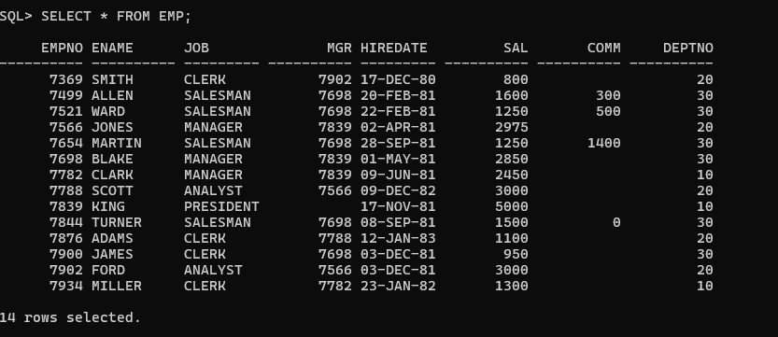

CREATE TABLE SALGRADE
(
GRADE NUMERIC,
LOSAL NUMERIC,
HISAL NUMERIC
);

INSERT INTO SALGRADE VALUES (1, 700, 1200);
INSERT INTO SALGRADE VALUES (2, 1201, 1400);
INSERT INTO SALGRADE VALUES (3, 1401, 2000);
INSERT INTO SALGRADE VALUES (4, 2001, 3000);
INSERT INTO SALGRADE VALUES (5, 3001, 9999);

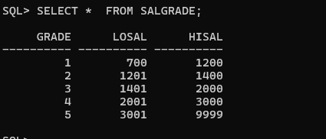

CREATE TABLE BONUS
(
ENAME VARCHAR(10),
JOB VARCHAR(9),
SAL NUMERIC,
COMM NUMERIC
);

